In order to minimise the risk to team members working from home, please review your work from home set-up and complete this checklist. Note that this checklist is a guide only and will require a pragmatic approach, in particular in our current environment, as every work from home situation is different.
If you have any concerns about your work from home set-up, please contact your Manager or the Health and Safety team.

Team Member Details

Name

Job Title

Hub

Manager
Completed On | INSERT DATE

Risk Assessment
Work Environment | Yes | No
Do you have a suitable desk set-up suited to your work? Consider the height of your desk, height and location of your screen(s), direction of light sources, etc.
Do you have a suitable chair to work from? If no, consider coming into the office and borrowing your chair from work while we are all working from home.

Note: You will need to do this before the end of the day on 24 March if possible.
Are your walkways clear of clutter and trip hazards? Consider trailing cords, children’s toys, etc.?
Do you have sufficient ventilation, and will you be able to control your thermal comfort while working from home?
Is your work environment segregated from other hazards in the house e.g. hot cooking surfaces, water sources, etc.?
Will there be other people in your work environment and/or close at hand in the event of an emergency?
Is the path to the emergency exit reasonably direct and accessible in the event of an emergency?

Safety and Security | Yes | No
Does your home security prevent unauthorised intruders?
Are you able to keep files, laptops, and computers in a secure place when they are not in use?
Do you have the contact details of emergency services, your local police station, and relevant MUSEUM contacts immediately accessible?
Do you understand that work-related incidents while working from home should continue to be reported to Health and Safety?
Are your smoke detectors working and checked at least twice a year?
Do you have access to first aid equipment and supplies if required?
Note: Unless otherwise agreed with your manager please be active on Teams while working from home. This will allow your manager and others in the team to connect with you as they would in the work environment.
Electrical | Yes | No
Do you have suitable power outlets that are not overloaded with double adaptors and power boards?
Are all of your connectors, plug sockets, and outlets in safe working order?

Physical and Mental Wellbeing | Yes | No
Are you aware of the benefits of breaking up your daily activities, including ensuring that you are standing up and walking around from time-to-time?
Are you able to maintain a comfortable posture at your desk? If no, please refer to the ergonomics guide below or contact Health and Safety for assistance with your set-up.

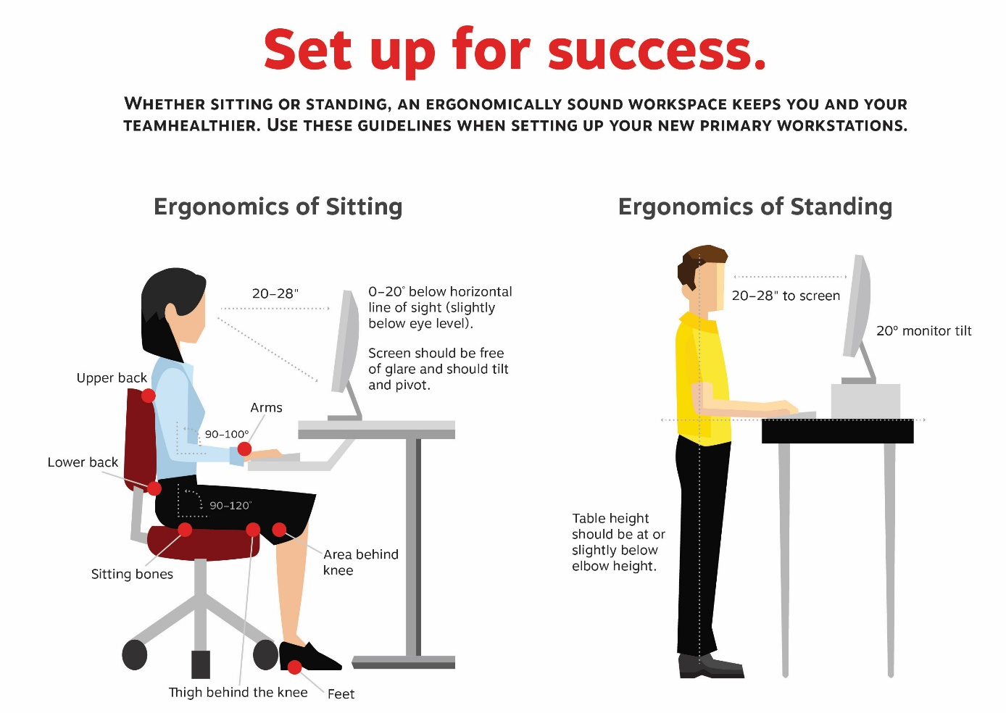
Note: Remember the importance of connecting with your colleagues each day. People and Culture will assist in supporting your mental wellbeing over the coming weeks, but the simple act of connecting will make a big difference to many of us.
Personal | Yes | No
Is there anything you are concerned about in relation to your work from home situation? If yes, please note below.
Do you have any special requirement in relation to your work from home situation? If yes, please note below.

Please send the completed form to your manager copying X in Health and Safety (email).

